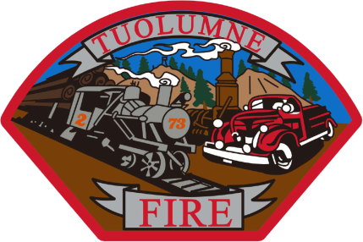

**Tuolumne Fire District**

18690 Main Street

Tuolumne, CA 95379

July Department Report

* July 6th  The 2024 Local Agency Biennial Notice and Request for updates to Conflict of Interest Code sent to the County to be filed.
* July 8th The on duty crew attended EMS training at station 81.
* July 11th The District hosted a Fire Chief’s Association meeting at the station.
* July 15th E-732 and E-733 were both driven to Hi Tech to have annual pump tests done.
* July 18th The annual service was done on E-733 in house at the station.
* July 19th The annual service was done on E-732 in house at the station.
* July 21st The department participated in the Touch A Truck Event held at Cover’s Apple Ranch
* July 22nd The on duty crew attended EMS training at station 81.
* July 26th SDRMA Payroll Reconciliation was completed for 24/25 and sent in.
* July 31st Hi Tech called and stated that the repairs were completed on E-731. It was picked up and driven back to the station and once here it was tested to be put in service and the throttle was still not responding. It was taken back to Hi Tech. Still waiting for a response and repairs.

Please contact me with any questions or concerns.

Respectfully,

Jeff Santi

Fire Chief