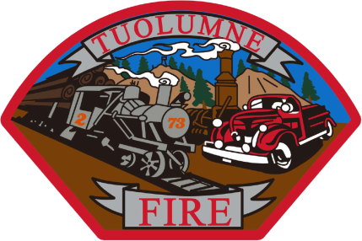

**Tuolumne Fire District**

18690 Main Street

Tuolumne, CA 95379

October Department Report

* October 4th Intern Centeno stepping down to start EMT school.
* October 4th Commercial inspections have started.
* October 5th Q4 reporting completed and submitted for OTS grant.
* October 5th Hammer Fire occurred with one fatality and one victim flown to burn center.
* October 8th New rebuilt motor arrived for E-732 and installation started.
* October 9th Engine repairs on going.
* October 10th All repair work completed on E-732 and motor was started for testing purposes.
* October 11th Continue with investigation after Hammer Fire.
* October 16th TEDA finished clearing left over construction materials and debris to have Tuolumne LZ re opened.
* October 17th Vehicle fire on Carter St- Stolen vehicle.
* October 21st Tuolumne LZ was used to fly a fall victim to a valley trauma center.
* October 29th E-732 put back into service after testing period.
* October 30 The on duty crew participated in the annual Tuolumne Halloween Parade.
* October 31st I have completed 23 commercial inspections this month. The remaining will continue into November.

Please contact me with any questions or concerns.

Respectfully,

Jeff Santi

Fire Chief